Vendor portal stories
Background: We already implemented SAP Public cloud to our client, PT Bumi Resource Minerals along with its 5 subsidiaries,
- PT Bumi Resource Minerals (Holding Company) - BRM
- PT Citra Palu Minerals (Gold mining in Palu, Sulawesi), already operate - CPM
- PT Gorontalo Minerals (Gold mining in Gorontalo, Sulawesi), still exploration - GM
- PT Suma Heksa Sinergi (Gold mining in Banten, Jawa) - SHS
- PT Linge Minerals (Gold mining in Aceh, Sumatera) - LMR
The SAP Public Cloud LoB that is implemented are:
- Finance
- Sourcing and Procurement
- Supply Chain Management
- Project Control
Following is the Org. Structure
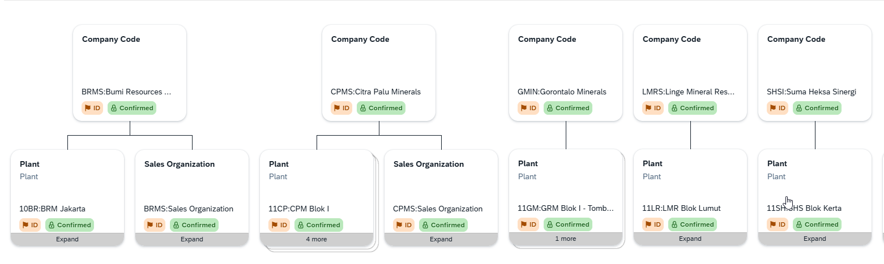
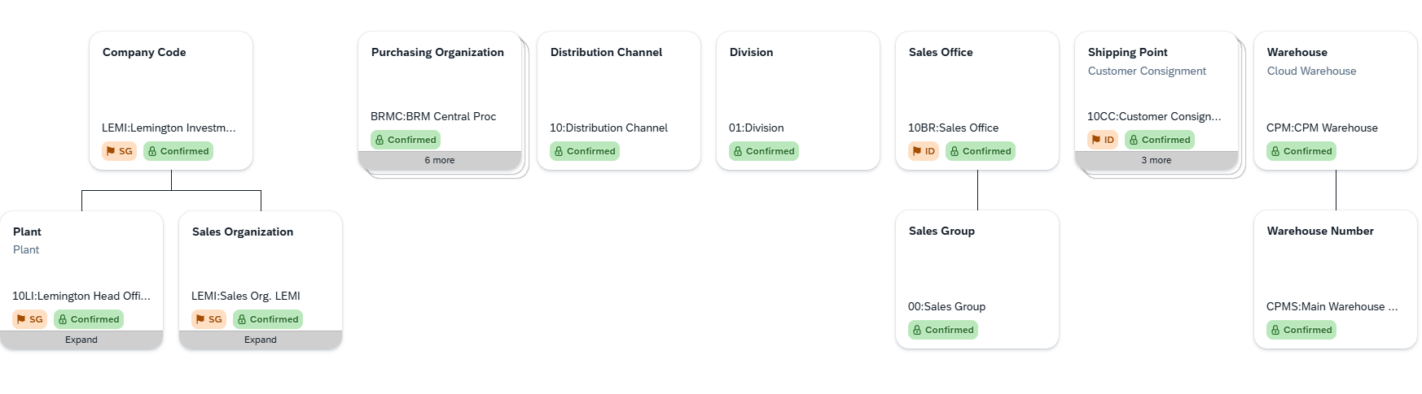
Please note that even there is sales organization, it is not used in the operation. It is created for the prerequisite several SCM process only.
Currently, they have several pain points regarding the procure to pay process as follows:
- Sourcing Management paint points
  - Multiple system
Procurement team operates 2 system (SAP & FARMS). SAP covers administration of the sourcing transaction (create PR, create RFQ, Create Quotation, Awarding Quotation, Create PO) and FARMS cover sourcing process (create tender which refer to RFQ SAP, Tender Committee assignment, Quotation Evaluation, Discussion box). So, there is potential fraud between 2 system, because these not integrated
  - Miscommunication
The Tender Committee lacks a centralized tool for evaluation and decision-making
  - Manual Communication
Vendors rely on manual notifications to receive status updates on invitations or tender outcomes

- Supplier invoice paint points
  - Invoice is very massive (200-300 invoices per weeks), and the AP admin is only 2. Since the verification should be fast, there is a excel file named “Guest invoice book” which record the invoice as the invoice come. There is a junior level to check the completeness of the invoice document.
  - There is a lag time between guest book input vs SAP input, i.e. data in guest book is roughly entered in SAP after 2-3 days as the data is very massive to be proceed by 2 AP Admin. Several vendor did ask the payment even the invoice not entered to SAP yet. Therefore, the payment also lagging, i.e. several payment is done outside system first before entered to SAP
  - Guest invoice book is inputted manually to SAP, which means AP admin will manually “scan by eye” of every PDF document in guest book and input in in SAP menu “Create Supplier Invoice”

I want to build vendor portal web application which must follow SAP Public Cloud standard visual design with approach of UI5 Web Components (https://ui5.github.io/webcomponents/components/).
The vendor portal web application has 2 main functions which are:
- Sourcing Management Dashboard
This dashboard has 3 different views (role-based views):
- Client View (BRM/CPM/GM/LMR/SHS)
- Tender Committee View
- Vendor View
View | Role / Persona | Description
Client View | BRM, CPM, GM, LMR, SHS | Internal company stakeholders. They monitor all sourcing activities, submit procurement requests, and track the status of tenders related to their business unit.
Tender Committee View | Tender Committee | Evaluation committee. They have access to review vendor proposals, conduct evaluations, and issue final decisions on active tenders.
Vendor View | Vendor / Supplier | External parties (vendors/suppliers). They receive tender invitations, download RFQ/RFP documents, and submit their bids through the portal.

- Invoice Management dashboard.
The dashboard has 2 different views, which are:
- Vendor view
- Client View (BRM/CPM/GM/LMRS/SHS)

The invoice management has the following process flow
No | Activity | Agent | Activity detail
1 | Submitting invoice | Vendor | Submit invoice with the following parameter  - Company Code  - Currency  - Vendor Invoice no  - Invoice amount  - VAT base amount  - VAT amount  - WHT Type  - WHT Code  - WHT Base Amount  - WHT Amount  - PO Reference (multiple selection) -> it will get SAP PO data of the particular vendor which already successfully GR process and open invoice  - Faktur Pajak No  - Attachment Invocie  - Attachment Faktur Pajak  - Notes (free text)  The invoice will become custom object of “pre invoice”. The invoice should be proceed to the next step before actually become SAP Invoice (MIR7 document)  However, For supplier with country other than ID, there will be no check for PO should be GR. So they can make an invoice even PO is not yet GR-ed. On this scenario, in SAP will become Supplier Down Payment Request. After the Down Payment request is approved by client, it will route the workflow in Vendor Portal
2 | Review Invoice | Client | See the supplier invoice list submitted by vendor. They can pop up see the PDF attached for Invoice & Faktur pajak. They also check the amount in attachment = the amount inputted in the system.  Client can reject the pre-invoice document or approve. Client can add comment for rejected document.  If rejected, the invoice go back to vendor in the portal. There will be notification also in the vendor for the rejected invoice. They also can see the client comment.  They can edit the invoice, and resubmit again  If the client approve,  - If It is invoice: the invoice will hit SAP API for Supplier Invoice Create, along with the attached document as parked-complete in SAP and continue the workflow of supplier invoice flexible workflow in SAP  - The document then will sent to SAP Build Process Automation for the workflow of supplier Down Payment request in BTP. The workflow will then proceed using SAP BPA until the document is posted.
3 | Edit / cancel invoice | Vendor | As long as the invoice not yet proceed by client (status is submitted), vendor can withdraw (cancel) or edit the invoice.
4 | Manage Vendor Invoice | Client | The menu will list all the vendor invoice from all vendor. It will also connect the “Pre invoice document” (both for invoice & supplier DPR) to the SAP document. So if it is a invoice, it will connect to SAP MIRO document (i.e. 51xxxx /20xx). If it is supplier DPR, then it will connect to SAP FI document (i.e. BRMS/100xxxx/20xx)  Each time the apps is opened, it will get the SAP document number through API so that can determine whether the status is posted or on progress.  The list will contain also the status of the document. the status will consists as follows:  - Open (not yet reviewed by client)  - On progress (reviewed by client, but pending on workflow)  - Posted (the document is posted)  - Converted to Invoice (only for Supplier DPR, -> active when flow no 5 below for converting the invoice is success)  - Cleared to invoice (only for DPR -> active when flow no 5 below for clearing document is success)  There will be also several date data, which are  - Invoice date  - Vendor submission date  - Invoice fully approved date
5 | Convert DP to Invoice | Client | The apps will lists all the Supplier down payment request (DPR) from vendor that is already posted (status Posted on flow no 3 above)  The list will also get the SAP supplier invoice number, so client can match between DPR & Invoice.  There will be a button to create supplier invoice as a post (not as a parked as complete) to create the corresponding invoice document. It will hit API to SAP to create supplier invoice. The resulted document will be send back to the portal and listed in the list.  There will be also “Clear button” to clear the DPR to Invoice. It will hit SAP API to clear journal entry. If the clearing is success, the clearing document will be send back to the portal and the document number (BRMS/12xxxx/20xx) can be shown in the lists

There will be several validation i.e.
- The PO which already taken for invoice by vendor, is cannot be selected again for the new invoice, even the invoice only at draft status.
- There will be validation that the actual supplier invoice no cannot entered twice

Vendor can managed all of his supplier only, while the client can view all the invoice from all vendor for specified company code (so the authorization for client is per company code

